Session 1
class Solution {
public boolean halvesAreAlike(String s) {
int n = s.length();
int vowelCount = 0;
String vowels = "aeiouAEIOU";

for (int i = 0; i < n / 2; i++) {
if (vowels.indexOf(s.charAt(i)) != -1) {
vowelCount++;
}
if (vowels.indexOf(s.charAt(i + n / 2)) != -1) {
vowelCount--;
}
}

return vowelCount == 0;
}
}

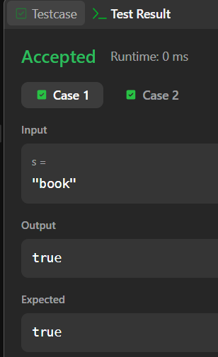

Session 1 -2
import java.io.BufferedReader;
import java.io.IOException;
import java.io.InputStreamReader;

public class Main {
public static void main(String[] args) throws IOException {
BufferedReader br = new BufferedReader(new InputStreamReader(System.in));

String tStr = br.readLine();
if (tStr == null || tStr.trim().isEmpty()) return;
int t = Integer.parseInt(tStr.trim());

StringBuilder sb = new StringBuilder();

while (t-- > 0) {
String s = br.readLine();
if (s == null) break;
s = s.trim();

if (isLapindrome(s)) {
sb.append("YES\n");
} else {
sb.append("NO\n");
}
}

System.out.print(sb.toString());
}

private static boolean isLapindrome(String s) {
int n = s.length();
int[] count = new int[26];

int halfLen = n / 2;

int secondHalfStart = (n % 2 == 0) ? halfLen : halfLen + 1;

for (int i = 0; i < halfLen; i++) {

count[s.charAt(i) - 'a']++;

count[s.charAt(secondHalfStart + i) - 'a']--;
}

for (int c : count) {
if (c != 0) {
return false;
}
}

return true;
}
}
